**Final Report: Comparative Analysis of Loblaw Sales and External Economic Factors**

Group #5 - BIDA 301: Business Intelligence and Data Analytics Fundamentals

Date: December 8, 2024

**Introduction**

Food affordability concerns have risen significantly in Canada over the recent years (AAFC, 2024). There are some speculations that grocery retailers have been implementing predatory pricing and price gouging. With the COVID-19 pandemic disruptions, Canadian households have faced economic pressures in the dramatic rise in grocery prices along with increasing inflation, global supply chain issues, and fluctuating incomes.

As a leading grocery retailer, Loblaw Companies Limited has experienced changes in its sales performance, reflecting these macroeconomic trends. Understanding the relationship between Loblaw's sales and these external factors can provide valuable insights into recent consumer behavior and grocery pricing increases.

**Problem Statement**

How do Food Consumer Price Index (CPI) fluctuations, global supply chain disruptions, and real disposable household income changes influence Loblaw’s food sales performance?

* + How is Loblaw’s food sales growth affected by CPI (all-items and food only)?
  + How does real household disposable income impact spending at Loblaw?
  + What role does global supply chain issues play in Loblaw’s performance trends?

The primary objective of the project is to analyze food sales of Loblaw from 2015 to 2014 and evaluate its relationship with key economic factors such as Consumer Price Index (CPI) particularly the food segment, Real Household Disposable Income (RHDI) and Global Supply Chain Pressure Index (GSCPI). By using publicly available data, the analysis aims to identify trends and key drivers influencing Loblaw's financial outcomes over the years and provide actionable insights for Canadian consumers, economic analysts, policy makers, and Loblaw decision-makers. The project understand the needs of its stakeholders, who will benefit from the analysis as follows:

* **Canadian consumers** will gain a better understanding behind grocery pricing increases, and the media to access credible narratives about consumer and market dynamics
* **Loblaw’s managemen**t will be equipped with insights that support strategic decisions to adapt pricing, supply chain management and customer outreach to rebuild trust in light of price gouging speculations.
* **Economic analysts and researchers** will be informed about trends and correlations in Loblaw’s food sales performance and enable them to plan for similar future scenarios.
* **Policymakers** **and regulating bodies** will obtain data-driven recommendations to craft and refine policies addressing inflation, food affordability, and supply chain resilience.

**Analytical Approach**

Annual and quarterly data on key variables namely Loblaw’s food sales, CPI (all-items and food only), real household disposable income and global supply chain pressure index (GSCPI) were collected and explored from multiple sources including Statista, Statistics Canada and Sedar+.

Loblaw’s food sales - total revenue generated by Loblaw Companies Limited from the sale of food products through its grocery retail operations. This includes sales across all food categories such as fresh food, packaged goods, and prepared meals

* <https://www.loblaw.ca/en/investors-reports/> (2022-2024
* <https://www.sedarplus.ca> (pre-2022)

Consumer price index (CPI) - Consumer Price Index (all-items) measures the average change over time in the prices paid by consumers for a wide range of goods and services, including food, housing, transportation, and medical care. The Food Consumer Price Index (Food CPI) measures the average change over time in the prices paid by consumers for food products.

* <https://www150.statcan.gc.ca/t1/tbl1/en/tv.action?pid=1810025601>

Real household disposable income (RHDI) - the income available to households after taxes, adjusted for inflation. It represents the amount of money that households have available to spend or save, considering changes in price levels.

* <https://www150.statcan.gc.ca/t1/tbl1/en/tv.action?pid=3610010501>

Global supply chain pressure index (GSCPI) - a composite index that tracks global supply chain disruptions. It combines several factors such as transportation costs, delivery times, and supply shortages to measure the overall stress on global supply chains.

* <https://www.statista.com/statistics/1315308/global-supply-chain-pressure-index/>

Limitations:

* Loblaw’s financial data do not attribute sales fluctuations to external economic factors.
* The financial performance of one grocery conglomerate (Loblaws) is not indicative of the performance of the grocery retail market overall.
* Global supply chain disruption indicators may not fully capture the complexities of Loblaw’s operations and localized issues in Canada.

**Regression Analysis**

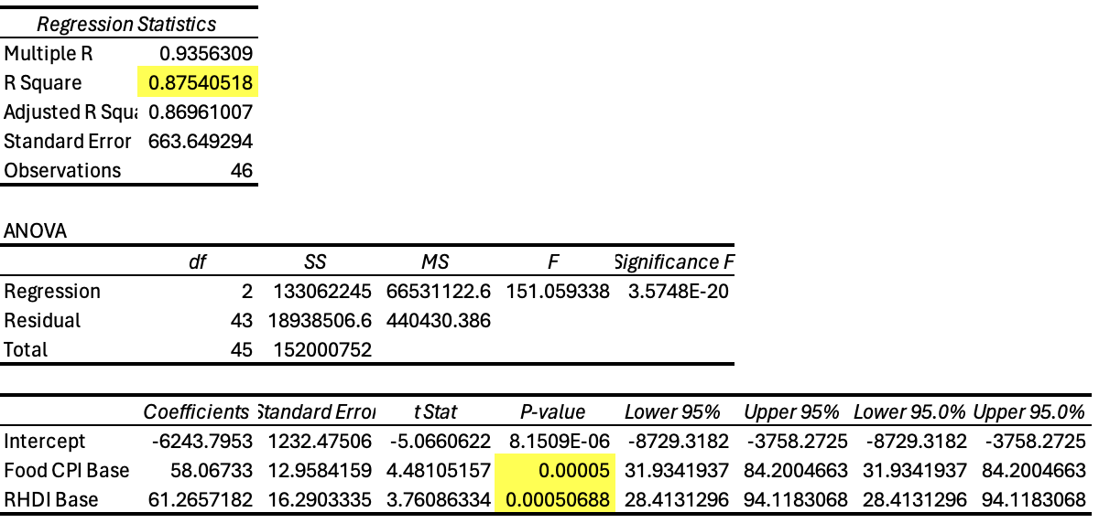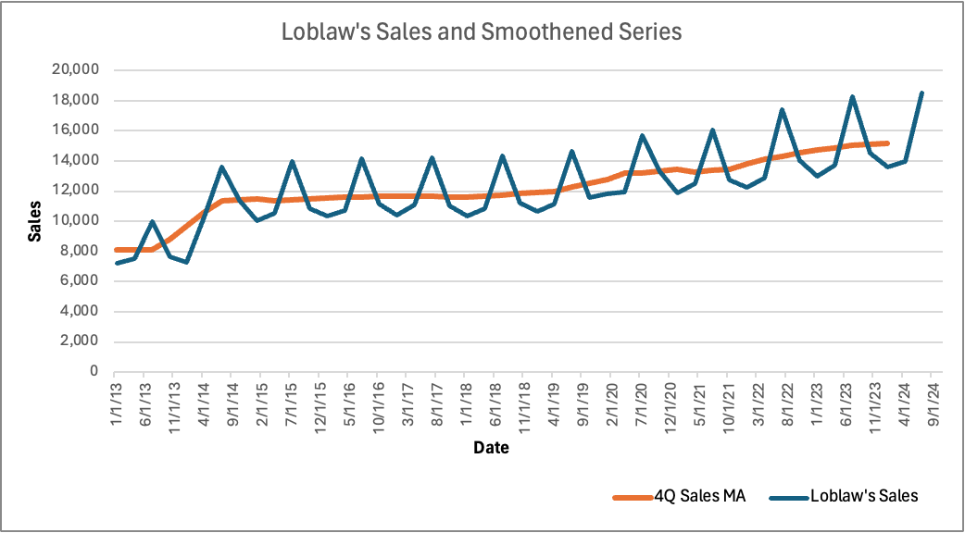

To determine whether any of the three independent variables (CPI, RHDI and GSCPI) correlate with Loblaw’s sales, regression analysis is done using the 4-quarter sales moving average to adjust the sales data with seasonality (as shown above). Using the smoothened series, Loblaw’s sales resulted in a strong correlation (R square = 88%) between Food CPI and RHDI, both variables having P-values less than 0.05. Global supply chain pressure index (GSCPI) has a P-value higher than 0.05, which means it is not a significant predictor of Sales, so we removed the GSCPI variable to show a more accurate model. In the regression output above, all the P-values are now showing below 0.05., while the R square value also remains at 0.8754, a strong fit of correlation, which means 88% of observations in Loblaw’s smoothened Sales series are explained by Food CPI and RHDI.

**Sales Forecasting**

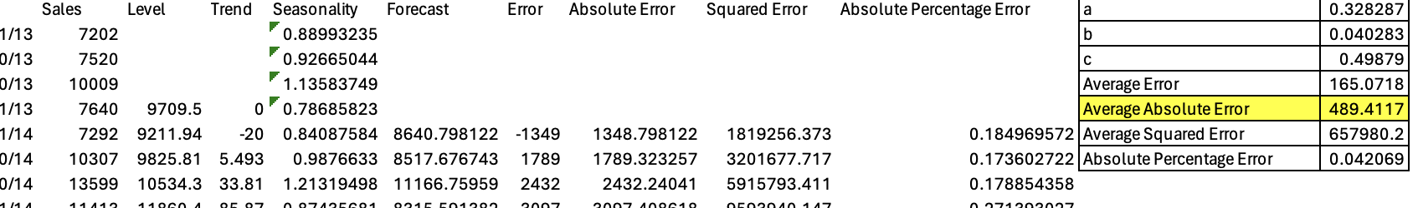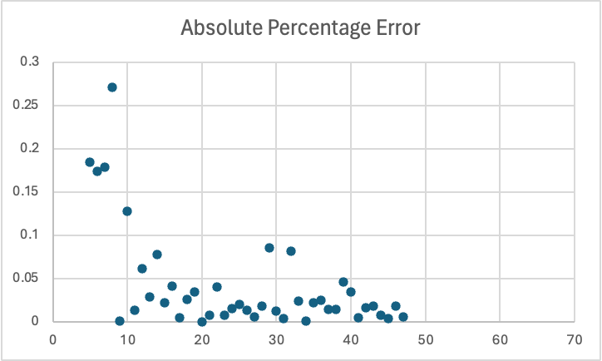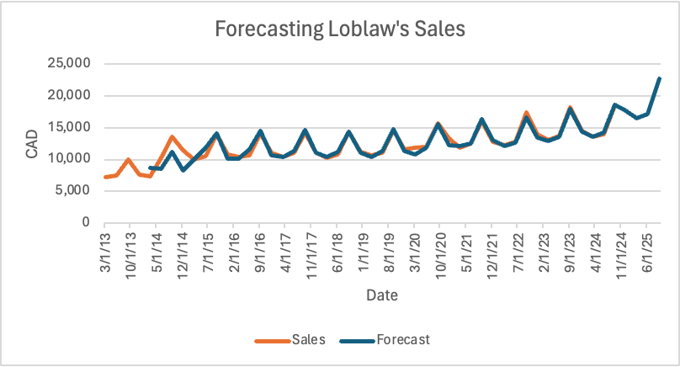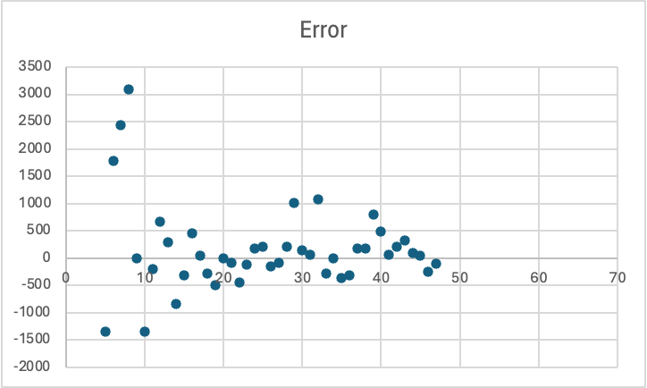

Using Holt-Winter’s method, optimal values for values for alpha, beta and gamma are found and a 12-month forecast for sales is created. This will be used to optimize Loblaw’s inventory levels and drive promotion strategies to anticipate demand on the forecasted sales. Even so, with heteroskedasticity in the scatter plots, the model would not be able to fully capture the data's dynamics. Thus, qualitative factors must be considered, understanding the business issue to look at retail industry trends, competition, regulatory policies and consumer behavior that may help manage sales forecasting moving forward.

**Key Findings**

[Click link to Tableau dashboard](https://public.tableau.com/app/profile/skylar.carroll/viz/BIDA301-Loblaw/LoblawSalesandExternalEconomicFactors)

* 2015–2019:
  + Steady CPI Growth: Yearly % change fluctuated between 1.9% to 3.9%, showing moderate growth.
* 2020–2023:
  + Supply Chain Issues: Highlighted period of disruption, correlating with significant increases in food CPI:
    - 2022: 8.5% growth in food CPI.
    - 2023: 8.0% growth in food CPI.
  + This sharp increase aligns with pandemic impacts, labor shortages, and globalsupply chain issues.
* 2024:
  + CPI Growth Moderation: The % change drops to 3.0%, suggesting easing supply chain pressures and inflation rates.

The analysis reveals a complex interplay between consumer behavior and macroeconomic trends. Consumers are rapidly losing buying power as food prices rise faster than other goods, with the Food Consumer Price Index (CPI) outpacing overall inflation. Despite these challenges, Loblaw has benefited from increased prices, capitalizing on food inflation and shifts in consumer behavior during the COVID-19 pandemic. Retail food sales tripled during this period, driven by increased Real Household Disposable Income (RHDI) and a surge in grocery demand as households adjusted to lockdowns. In 2023, retail food sales continued to grow, largely due to a spike in food inflation, emphasizing how rising costs disproportionately impact consumers while bolstering revenue for grocery retailers.

**Recommendations**

For Loblaw:

**Dynamic Pricing:**

Adjust prices based on CPI trends to balance revenue growth and affordability.

**Resilient Supply Chain Management:**

Invest in technology to reduce supply chain vulnerabilities and ensure product availability. Grocery retailers could consider investing in the development of predictive or seasonal analytics models, especially as the impacts of climate change accelerate around the globe. Climate change is already impacting agriculture, and subsequently food supply chains, leading to fluctuations in grocery pricing. By leveraging predictive analytics, Loblaw may be able to better anticipate these disruptions and adapt their strategies proactively.

**Adaptive Pricing and Targeted Marketing:**

Develop campaigns focused on price reductions on essential items like bread, milk, or produce during times of high food CPI. This can demonstrate their support to customers and minimize future public speculation on price gouging in times of high inflation.

For Future Research:

**Comparative Analysis:**

Analyze sales performance across other major Canadian grocery retailers, government policies and relevant consumer behavior.

**Predictive Analytics:**

Build forecasting models to predict sales under future economic scenarios. Consider adapting existing seasonal predictive models, to account for scenarios such as droughts, floods, and heatwaves.

**Conclusion**

The project underscores the influence of macroeconomic factors such as CPI and RHDI on Loblaw's sales performance, revealing key insights into food affordability and consumer behavior amid inflation and supply chain disruptions. The strong correlation between these variables highlights the impact of economic pressures on both consumer spending and corporate strategies. While global supply chain disruptions were less predictive, their broader role in shaping market dynamics remains significant. The analysis emphasizes the need for Loblaw to balance profitability with consumer affordability, especially as buying power continues to erode. Ethical integrity was maintained throughout the project by using publicly available data and ensuring an unbiased approach. The findings highlight how economic pressures are reshaping consumer behavior, corporate strategies, and public perceptions. This analysis provides a foundation for understanding grocery price dynamics, while also offering actionable insights for Loblaw and policymakers. The growing disparity between food inflation and general inflation calls for collaborative solutions to improve access to affordable food. Future research with more accessible public data can further explore the effects of government policies, competition, and consumer behavior on the grocery retail sector.

**References**

Agriculture and Agri-Food Canada. (2024, July 24). 2023 Survey with Canadian consumers – Wave II. agriculture.canada.ca. Retrieved from <https://agriculture.canada.ca/en/sector/consumer-trends-and-behaviours/2023-survey-canadian-consumers-wave-ii>